# عبد العزيز مطيع الفهد

using System;  
using System.Windows.Forms;  
  
namespace WindowsFormsApp9  
{  
    public partial class Form1 : Form  
    {  
        public Form1()  
        {  
            InitializeComponent();  
        }  
  
        private void button1_Click(object sender, EventArgs e)  
        {  
            double n1, n2, n3;  
            string op1 = textBox2.Text;  
            string op2 = textBox4.Text;  
            string m1 = "";  
            string m2 = "";  
  
            if (double.TryParse(textBox1.Text, out n1) &&  
                double.TryParse(textBox3.Text, out n2) &&  
                double.TryParse(textBox5.Text, out n3))  
            {  
                  
  
                if (op2 == "*" || op2 == "/")  
                {  
                    m1 = perfromopr(n2, n3, op2).ToString();  
  
                    if (m1 == "NaN")  
                    {  
                        MessageBox.Show("العملية الثانية غير صحيحة");  
                        textBox4.Focus();  
                        return;  
                    }  
  
                    m2 = perfromopr(n1, Convert.ToDouble(m1), op1).ToString();  
  
                    if (m2 == "NaN")  
                    {  
                        MessageBox.Show("العملية الأولى غير صحيحة");  
                        textBox2.Focus();  
                        return;  
                    }  
                }  
                else  
                {  
                    m1 = perfromopr(n1, n2, op1).ToString();  
  
                    if (m1 == "NaN")  
                    {  
                        MessageBox.Show("العملية الأولى غير صحيحة");  
                        textBox2.Focus();  
                        return;  
                    }  
  
                    m2 = perfromopr(Convert.ToDouble(m1), n3, op2).ToString();  
  
                    if (m2 == "NaN")  
                    {  
                        MessageBox.Show("العملية الثانية غير صحيحة");  
                        textBox4.Focus();  
                        return;  
                    }  
                }  
            }  
            else  
            {  
                MessageBox.Show("يرجى إدخال أعداد صحيحة");  
            }  
  
            textBox6.Text = m2;  
        }  
  
        private double perfromopr(double nam1, double nam2, string opr)  
        {  
            switch (opr)  
            {  
                case "+":  
                    return nam1 + nam2;  
                case "-":  
                    return nam1 - nam2;  
                case "*":  
                    return nam1 * nam2;  
                case "/":  
                    return nam2 != 0 ? nam1 / nam2 : double.NaN;  
                default:  
                    return double.NaN;  
            }  
        }  
  
        private void button2_Click(object sender, EventArgs e)  
        {  
            this.Close();  
        }  
    }  
}

using System;

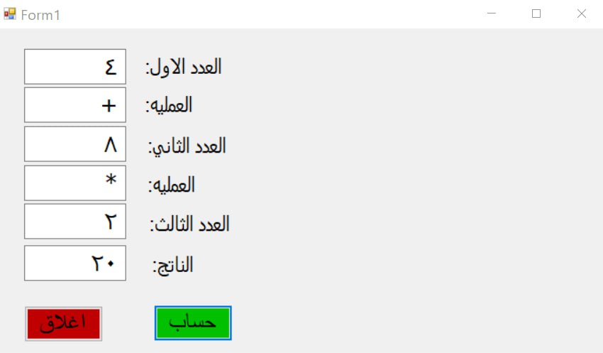

using System.Collections.Generic;  
using System.ComponentModel;  
using System.Data;  
using System.Drawing;  
using System.Linq;  
using System.Text;  
using System.Threading.Tasks;  
using System.Windows.Forms;  
  
namespace WindowsFormsApp15  
{  
    public partial class Form1 : Form  
    {  
        double x, y,z;  
         
  
        public Form1()  
        {  
            InitializeComponent();  
            listBox1.Items.Add("+");  
            listBox1.Items.Add("-");  
            listBox1.Items.Add("*");  
            listBox1.Items.Add("/");  
            listBox1.SelectedIndex = 0;  
        }  
  
        private void button2_Click(object sender, EventArgs e)  
        {  
            textBox1.Text = textBox2.Text = textBox3.Text = null;  
        }  
  
        private void button3_Click(object sender, EventArgs e)  
        {  
            this.Close();  
        }  
  
        private void button1_Click(object sender, EventArgs e)  
        {  
  
            try  
            {  
                x = Convert.ToDouble(textBox1.Text);  
            }  
            catch (Exception)  
            {  
                MessageBox.Show("تحزير", "العدد الاول غير صحيح", MessageBoxButtons.OK, MessageBoxIcon.Hand);  
                textBox1.Text = "";  
                textBox1.Focus();  
                return;  
            }  
  
            try  
            {  
                y = Convert.ToDouble(textBox2.Text);  
                 
                  
            }  
            catch(Exception)  
            {  
                MessageBox.Show("تحزير", "العدد الثاني غير صحيح", MessageBoxButtons.OK, MessageBoxIcon.Hand);  
                textBox2.Text = "";  
                textBox2.Focus();  
                return;  
            }  
            switch (listBox1.SelectedIndex)  
            {  
                
                case 0:z= x + y;  
                    break;  
                case 1:z=x - y;  
                    break;  
                case 2:  
                    z = x * y;  
                    break;  
                case 3:  
                    if (y != 0)  
                        z = x / y;  
                    else  
                    {textBox3.Text =textBox2.Text="";  
                        z = 0;  
                        MessageBox.Show("لا يقبل القسمه على 0");  
                         textBox2.Text = textBox3.Text = null;  
  
                        textBox2.Focus();  
                    }  
                          
                    break;  
  
                 
            }  
            textBox3.Text = z.ToString();  
        }  
  
        private void Form1_Load(object sender, EventArgs e)  
        {  
             
              
  
        }  
    }  
}

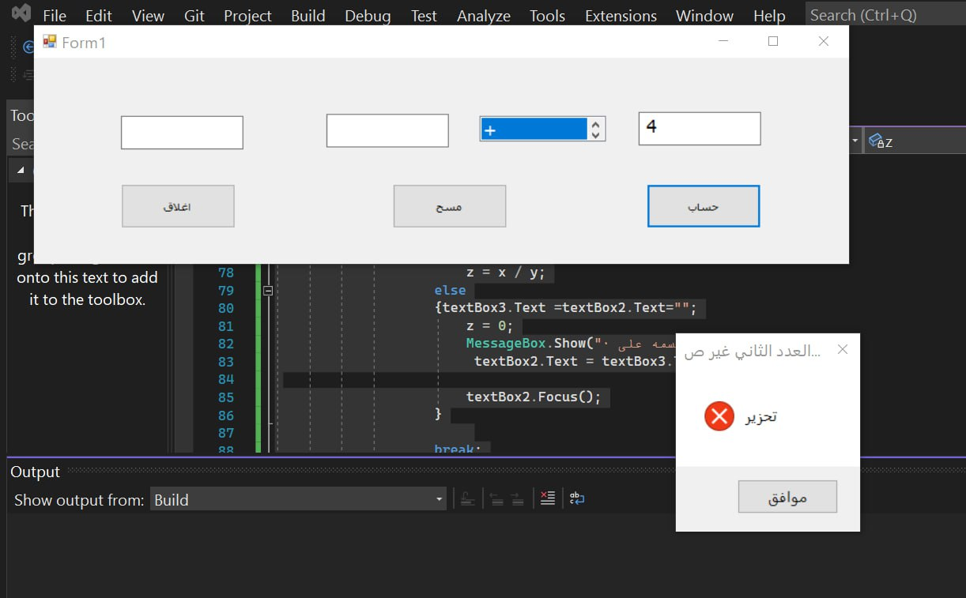

using System;  
using System.Collections.Generic;  
using System.ComponentModel;  
using System.Data;  
using System.Drawing;  
using System.Linq;  
using System.Text;  
using System.Threading.Tasks;  
using System.Windows.Forms;  
  
namespace WindowsFormsApp16  
{  
    public partial class Form1 : Form  
    {  
        public Form1()  
        {  
            InitializeComponent();  
        }  
  
        private void button1_Click(object sender, EventArgs e)  
        {  
            int f=0;  
            int z = Convert.ToInt32(textBox1.Text);  
              
            for(int i=0;i<z;i++)  
            {  
                f = f + i;  
            }  
            label1.Text = f.ToString();  
        }  
  
        private void button2_Click(object sender, EventArgs e)  
        {  
            int f = 1;  
            int z = Convert.ToInt32(textBox1.Text);  
  
            for (int i = 1; i <= z; i++)  
            {  
                f = f * i;  
            }  
            label2.Text = f.ToString();  
        }  
  
        private void button3_Click(object sender, EventArgs e)  
        {  
            int z = Convert.ToInt32(textBox1.Text);  
            label3.Text = Math.Sqrt(z).ToString();  
        }  
    }  
